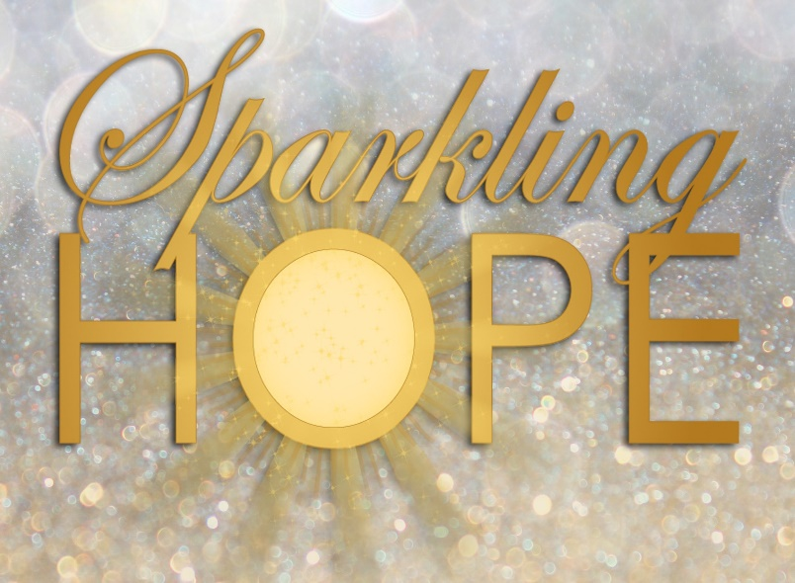

Betsy Kay Ridgway’s riveting account of her baby’s miraculous healing from a deadly brain tumor reads like a novel. The heartwarming and humorous stories of her boys’ special needs journey offers inspiration and profound insight. Self-help reflection follows each chapter. The *Topical Index* lends as a tool for Bible studies or book clubs. A real page turner!

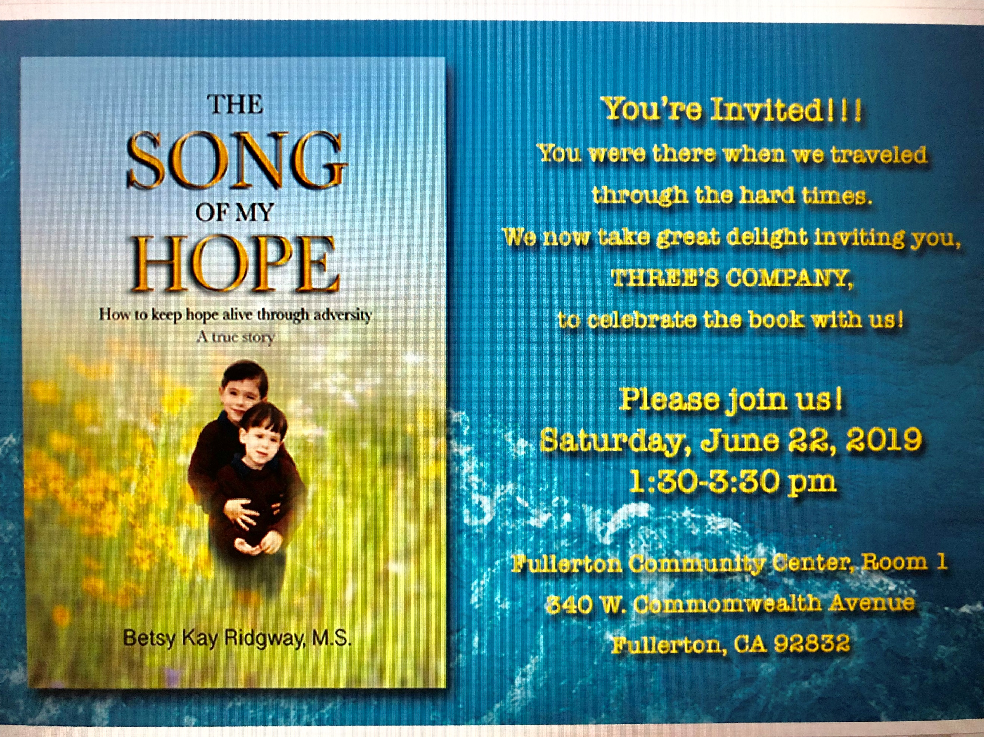

Amazon/Barnes & Noble

**Betsy Kay Ridgway, M.S.** is the author of *The Song of My Hope*. Her *Sparkling Hope* website is rich with insightful blogs and a packed Resource page. Starting as a Special Needs Consultant, Betsy has been advocating for the special needs community over ten years and speaking for over twenty years. She was also featured on the Podcast, *Queens Stand Up*.

**Media Story Ideas**

* Finding hope when life is falling apart.
* Calming down your child’s temper tantrum.
* Avoiding the loneliness of motherhood.
* Effects of jealousy can ruin your health.
* Avoiding holiday hell in your home.
* How social isolation can kill you.
* Freeing yourself from guilt and shame.
* The secret to a stronger brain.
* The absolute necessity of self-care.

***Hope transforms the impossible into unending possibilities.”***

***Betsy Kay Ridgway, M.S.***

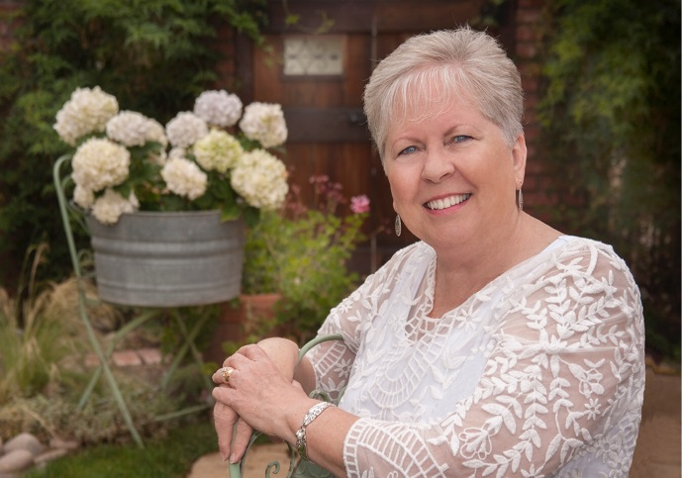

**BETSY KAY RIDGWAY, M.S.**

**Special Needs Family Advocate**

[www.sparklinghope.net](http://www.sparklinghope.net) [www.amazon.com/author/betsykayridgway](http://www.amazon.com/author/betsykayridgway)

[www.facebook.com/sparklinghope.net/](http://www.facebook.com/sparklinghope.net/) [www.instagram.com/_sparkling_hope_/](http://www.instagram.com/_sparkling_hope_/)

Contact: [betsy@sparklinghope.net](mailto:betsy@sparklinghope.net) Phone: (714) 345-5505